Introduction

ACTIVITY 1

Dual Mode Operation.

Dual Mode Operation is a mechanism used in operating systems to ensure system security and stability. In this method, the system operates in two different modes: User Mode and Kernel Mode. These modes control how programs access system resources and hardware.

Need for Dual Mode Operation
In a computer system, many user programs run simultaneously. If every program had unrestricted access to the system hardware, it could cause:
- System crashes
- Data corruption
- Security problems
To prevent this, the operating system separates privileged operations from normal user operations using dual mode operation.

Types of Modes
- User Mode
User Mode is the mode in which application programs execute.

Characteristics:
  - Limited access to system resources
  - Cannot directly access hardware
  - Cannot execute privileged instructions
  - Must request services from the operating system

Examples of user programs:
  - Web browsers
  - Text editors
  - Media players
  - Games

1

If a user program needs to perform operations like file access or memory allocation, it must request the operating system through system calls.

Kernel Mode
Kernel Mode is the privileged mode where the operating system runs.

Characteristics:
  - Full access to system hardware
  - Can execute all instructions
  - Handles system resources such as memory, CPU, and devices
  - Responsible for process management and device management

Examples of kernel operations:
  - Memory management
  - Process scheduling
  - Device control
  - File system management

Mode Switching
The CPU maintains a mode bit to indicate the current mode.

Mode bit = 1 → User Mode
  - Mode bit = 0 → Kernel Mode
When a user program requests a service from the operating system, a system call occurs. The CPU switches from User Mode to Kernel Mode. After completing the task, control returns to User Mode.

Steps:
- User program executes in User Mode.
- Program requests OS service (system call).
- CPU switches to Kernel Mode.
- Operating system performs the requested service.
- Control returns to User Mode.

2

Advantages of Dual Mode Operation
- Improves system security
- Protects operating system from user programs
- Prevents illegal access to hardware
- Ensures stable system operation
- Provides controlled access to system resources

Disadvantages
Although very useful, it has minor limitations:
  - Mode switching introduces small overhead.
  - Slightly increases system complexity.
However, the benefits greatly outweigh these limitations.

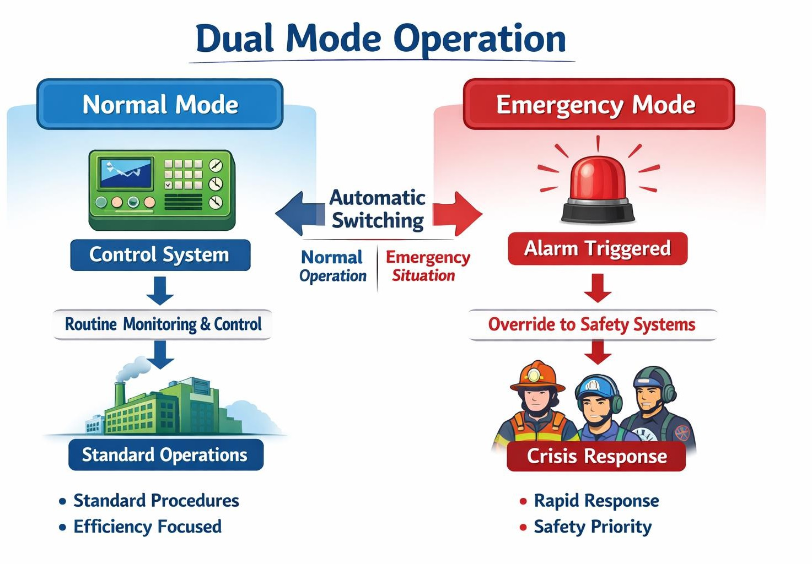

3

- Introduction

ACTIVITY 2

Linux User Manual.

A Linux User Manual is a document that provides instructions and guidance for users to operate and manage the Linux operating system. It explains how to use commands, manage files, control processes, and perform system administration tasks.

Features of Linux
Some important features of Linux include:
  - Open Source – The source code is freely available.
  - Multiuser – Multiple users can work on the system at the same time.
  - Multitasking – Multiple processes can run simultaneously.
  - Security – Strong permission and authentication mechanisms.
  - Portability – Runs on different hardware platforms.
  - Stability – Reliable system with fewer crashes.

Structure of Linux System
A Linux system consists of the following components:

Kernel
The kernel is the core of the operating system. It manages:
  - CPU scheduling
  - Memory management
  - Device management
  - Data storage device
  - System management
  - Secondary memory

4

  - Process control

Shell
The shell is the command interpreter that allows users to interact with the operating system. Examples of shells:
  - Bash
  - KornShell
  - C Shell
- File System
Linux organizes files in a hierarchical directory structure starting from the root directory (/). Important directories include:
  - /home – User files
  - /bin – Basic system commands
  - /etc – Configuration files
  - /dev – Device files
  - /tmp – Temporary files

Linux Command Structure
A typical Linux command follows this format: command [options] [arguments]
Example:
ls -l /home Where:
  - ls → command
  - -l → option
  - /home → argument

File and Directory Commands

5

Command Function
Ls List files and directories
pwd Show current directory
mkdir Create a directory
rmdir Remove directory
Cp Copy files
Mv Move or rename files
Rm Delete files

Example:
mkdir project
Creates a directory called project.
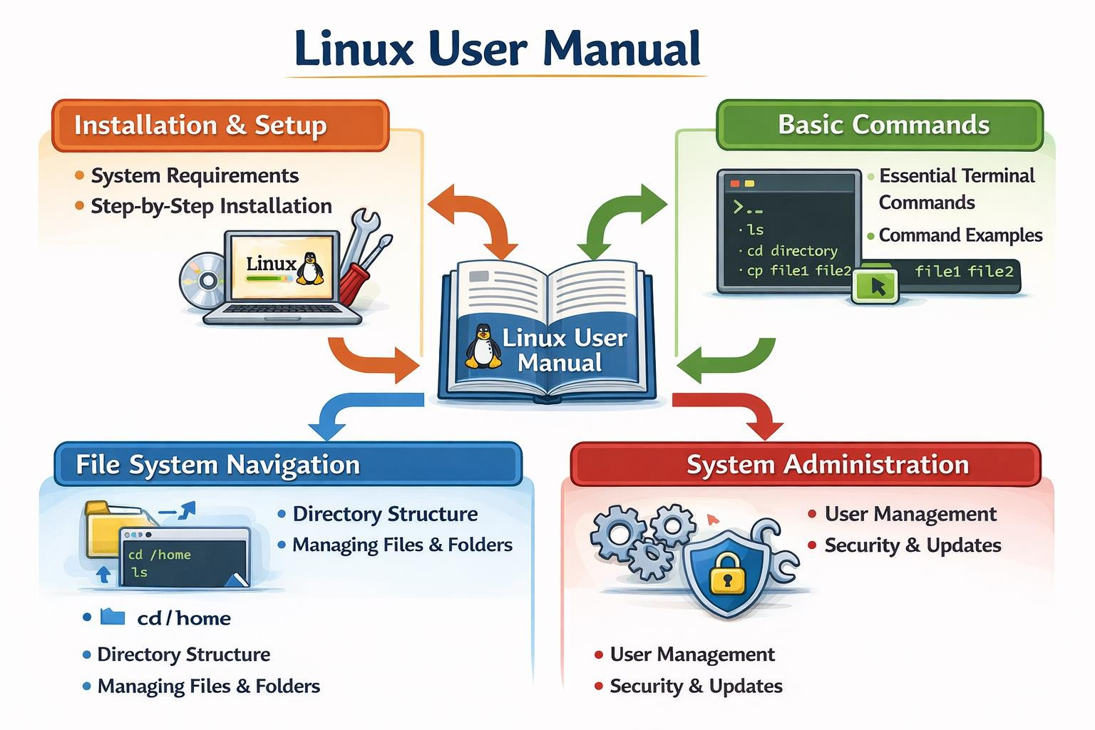

6

- Introduction

ACTIVITY 3

Path Names

In an operating system, files are organized in a hierarchical directory structure. To locate a file or directory, the system uses a path name. A path name specifies the exact location of a file or directory in the file system.
Operating systems like Linux, Microsoft Windows, and macOS use path names to access files and directories.
A path name acts like an address of a file in the directory structure.

Definition
A path name is the sequence of directory names that leads to the location of a file or directory in a file system.
It starts from the root directory and follows a path through various subdirectories until reaching the desired file.
Example:
/home/user/documents/file.txt
This path shows the location of file.txt inside the documents directory.

Components of a Path Name
A path name consists of the following components:

Root Directory
The root directory is the top-most directory in the file system hierarchy. Example:
  - / in Linux
  - C:\ in Microsoft Windows

Subdirectories

7

Subdirectories are directories inside another directory.

Example:
/home/user/documents Here:
  - home → directory
  - user → subdirectory
  - documents → subdirectory

File Name
The file name is the actual file stored inside a directory. Example:
file.txt

Types of Path Names
- Absolute Path Name
An absolute path specifies the complete path from the root directory to the file.

Characteristics
  - Always starts from the root directory.
  - Gives the complete location of the file.
  - Independent of the current working directory.

Example
In Linux:
/home/user/docs/report.txt In Microsoft Windows:
C:\Users\User\Documents\report.txt

Advantages
  - Exact file location

8

  - No confusion about file path

Relative Path Name
A relative path specifies the location of a file relative to the current working directory. Characteristics
  - Does not start with the root directory.
  - Depends on the current directory.

Example
If the current directory is:
/home/user Relative path: docs/report.txt
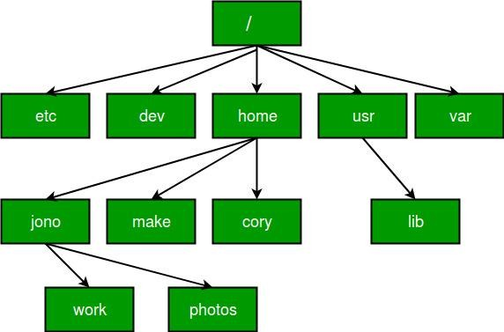

9

- Introduction

ACTIVITY 4

Process Management.

Process Management is one of the most important functions of an operating system. A process is a program that is currently being executed. The operating system manages multiple processes so that the system runs efficiently.
Operating systems such as Linux, Microsoft Windows, and macOS use process management to control program execution and allocate system resources like CPU and memory.

Process States
During its life cycle, a process goes through different states.

New
The process is being created.

Ready
The process is ready to run but waiting for CPU allocation.

Running
The process is currently being executed by the CPU.

Waiting (Blocked)
The process is waiting for an event such as I/O completion.

Terminated
The process has finished execution.

Process Control Block (PCB)
The Process Control Block (PCB) is a data structure used by the operating system to store information about a process.

Information stored in PCB
  - Process ID (PID)
  - Process state

10

  - Program counter
  - CPU registers
  - Memory management information
  - I/O status information
  - Scheduling information
The PCB helps the operating system manage and control processes efficiently.

Process Scheduling
Process scheduling determines which process gets the CPU at a given time.
The operating system maintains queues of processes and selects processes based on scheduling algorithms.

Types of Schedulers
- Long-Term Scheduler
  - Selects processes from the job pool.
  - Loads them into memory.

Short-Term Scheduler
  - Selects a process from the ready queue.
  - Allocates CPU to the selected process.

Medium-Term Scheduler
  - Suspends or resumes processes to manage memory usage.

Context Switching
Context switching is the process of saving the state of a currently running process and loading the state of another process.
Steps involved:
- Save the current process state in PCB.
- Select the next process.
- Load the process state from its PCB.

11

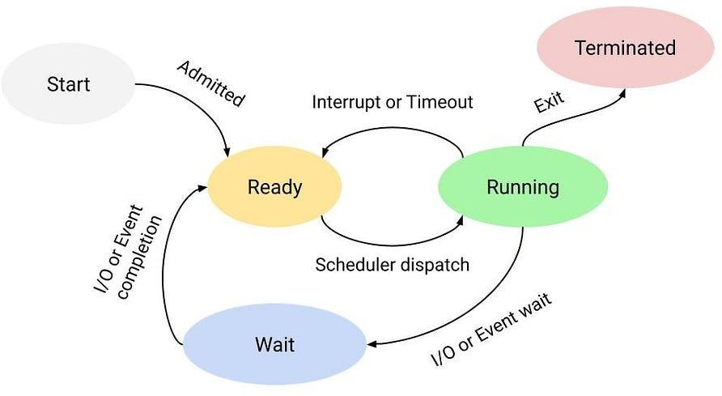
- Resume execution.
Context switching allows multitasking in operating systems.

Inter-Process Communication (IPC)
Processes often need to communicate with each other. Methods of IPC include:
- Shared Memory
- Message Passing
- Pipes
- Sockets
IPC helps processes exchange data and coordinate their actions.

12

- Introduction

ACTIVITY 5

Threads.

A thread is the smallest unit of execution within a process. It represents a single sequence of instructions that can be scheduled and executed independently by the CPU.
A process can contain multiple threads, allowing tasks to be performed concurrently. Threads share the same memory space and system resources of the process but execute different parts of the program.
Operating systems such as Linux, Microsoft Windows, and macOS support multithreading to improve system performance and responsiveness.

Components of a Thread
Each thread contains the following components:
  - Thread ID (TID) – Unique identifier of the thread.
  - Program Counter – Address of the next instruction to execute.
  - Registers – Store temporary data for execution.
  - Stack – Stores local variables and function calls. Threads share:
    - Code section
    - Data section
    - Open files
    - System resources

Multithreading
Multithreading is the ability of a process to execute multiple threads concurrently.

Example
In a text editor:
- One thread handles user input

13

- Another thread performs spell checking
- Another thread handles file saving
This improves application performance and efficiency.

Types of Threads
- User-Level Threads (ULT)
User-level threads are managed by user-level libraries rather than the operating system. Characteristics:
  - Fast creation and switching
  - Managed in user space
  - Kernel is unaware of these threads Example thread libraries:
  - POSIX Threads (Pthreads)

Advantages
  - Fast context switching
  - Simple implementation

Disadvantages
  - If one thread blocks, the entire process blocks
  - Cannot utilize multiple CPUs effectively

Kernel-Level Threads (KLT)
Kernel-level threads are managed directly by the operating system.
Operating systems like Linux and Microsoft Windows support kernel threads. Characteristics:
- Managed by the OS kernel
- Each thread can run on different processors
- Better concurrency

14

Advantages
- True parallelism
- Blocking one thread does not block others

Disadvantages
- Slower creation and management
- Higher overhead

Thread Models
Thread models describe the relationship between user threads and kernel threads. Types of models:
  - Many-to-One Model
  - One-to-One Model
  - Many-to-Many Model

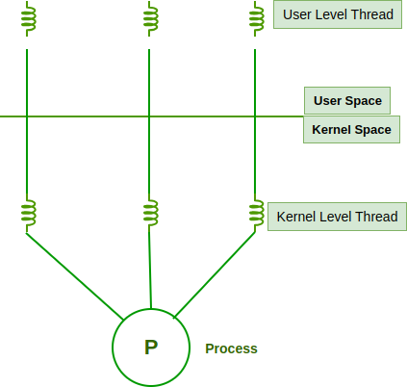

15

- Introduction

ACTIVITY 6

Paging.

Paging is a memory management technique used by an operating system to manage physical memory efficiently. It eliminates the problem of external fragmentation by dividing memory into fixed-size blocks.
In paging, both logical memory (used by the program) and physical memory (RAM) are divided into equal-sized units. These units are called pages and frames.
Operating systems such as Linux, Microsoft Windows, and macOS use paging to handle memory allocation efficiently.

Basic Concepts of Paging
- Page
A page is a fixed-size block of logical memory. Example:
Typical page sizes may be 4 KB, 8 KB, or 16 KB.

Frame
A frame is a fixed-size block of physical memory. Each page is loaded into one available frame in RAM.

Page Table
The page table is a data structure used by the operating system to map pages to frames. It contains:
  - Page number
  - Frame number
  - Status information

Address Translation in Paging
When a program accesses memory, the CPU generates a logical address. This address is divided into two parts:

16

Page Number
  - Offset
The page number is used to locate the frame number in the page table, and the offset determines the exact location within the frame.
Logical Address Structure:
Logical Address = Page Number + Offset Physical Address:
Physical Address = Frame Number + Offset

Paging Mechanism
Steps involved in paging:
  - CPU generates a logical address.
  - Logical address is divided into page number and offset.
  - Page number is used to search the page table.
  - Page table gives the corresponding frame number.
  - Frame number combined with offset gives the physical address.
  - Data is accessed from physical memory.

Advantages of Paging
  - Eliminates external fragmentation
  - Efficient memory utilization
  - Allows non-contiguous memory allocation
  - Supports virtual memory
  - Simplifies memory management

Disadvantages of Paging
  - Internal fragmentation may occur

17

  - Requires additional memory for page tables
  - Address translation increases overhead

Paging Hardware Support
Paging requires hardware support such as:
- Memory Management Unit (MMU)
- Page Table Register (PTR)
- Translation Lookaside Buffer (TLB)
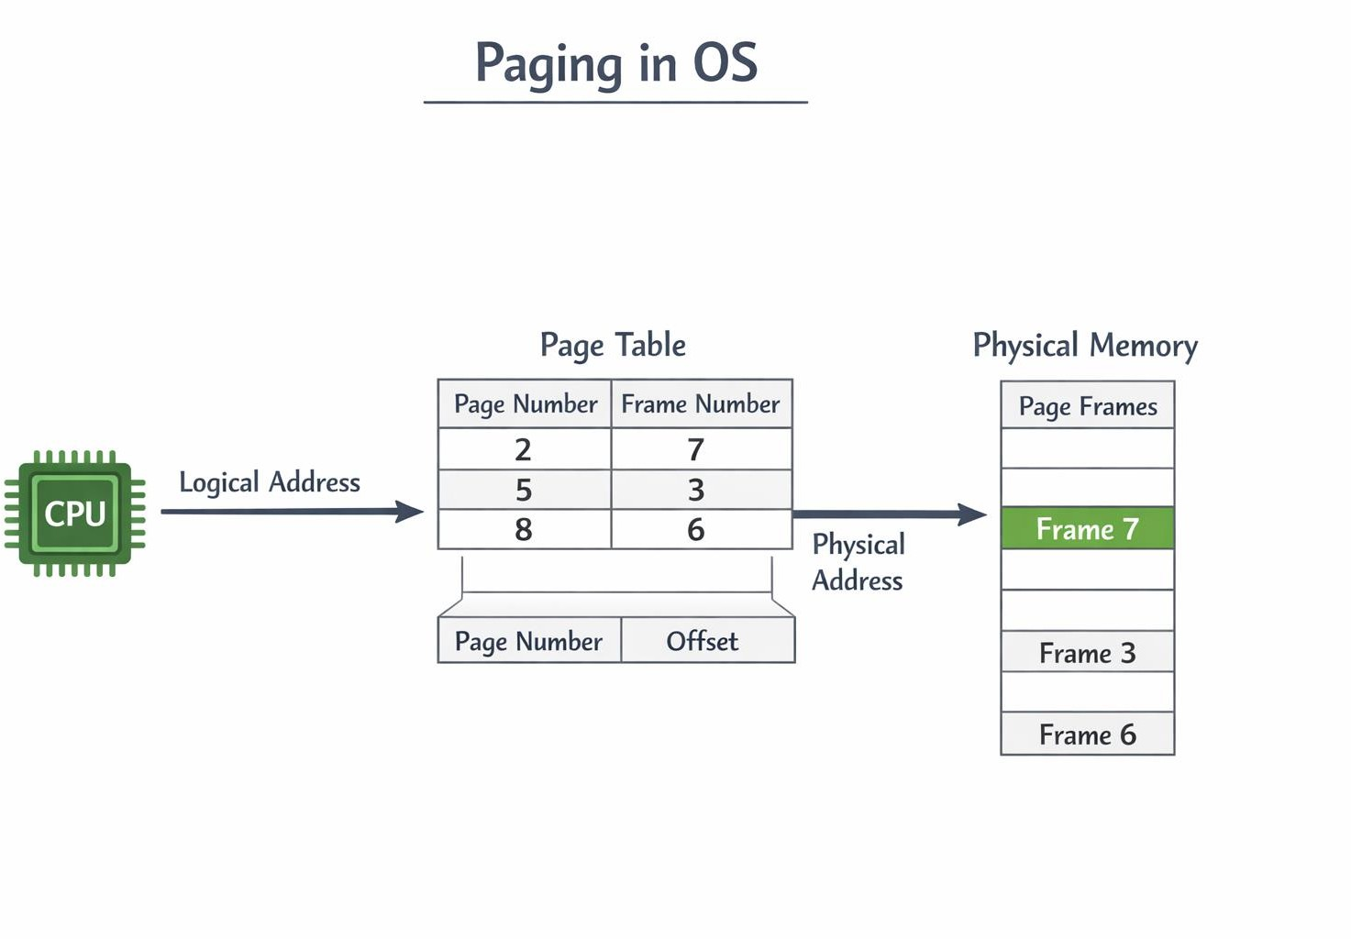
The MMU translates logical addresses into physical addresses using the page table.

18

- Introduction

ACTIVITY 7

Controlling Loops: Break and Continue.

In programming, loops are used to execute a set of statements repeatedly until a specified condition becomes false. Sometimes, it is necessary to control the execution of loops so that certain statements can be skipped or the loop can be terminated early.
Two important control statements used for this purpose are break and continue. These statements are commonly used in programming languages like C, C++, and Java.

Break Statement Definition
The break statement is used to terminate a loop immediately and transfer control to the statement that follows the loop.
It can be used in:
  - for loops
  - while loops
  - do-while loops
  - switch statements
Syntax break; Working
When the break statement is encountered:
- The loop execution stops immediately.
- Control moves to the next statement after the loop.

Example
#include <stdio.h> int main() {
int i;
for(i = 1; i <= 10; i++) {

19

if(i == 5) { break;
}
printf("%d ", i);
}
return 0;
}

Output
1 2 3 4
Explanation:
When i becomes 5, the break statement stops the loop.

Continue Statement Definition
The continue statement is used to skip the current iteration of a loop and continue with the next iteration.
Syntax continue; Working
When the continue statement is executed:
- The remaining statements in the current loop iteration are skipped.
- Control moves to the next iteration of the loop.

Example
#include <stdio.h> int main() {
int i;
for(i = 1; i <= 5; i++) { if(i == 3) {
continue;
}
printf("%d ", i);
}

20

return 0;
}

Output
1 2 4 5

Difference Between Break and Continue. Explanation:
When i equals 3, the continue statement skips printing 3 and moves to the next iteration.

Feature | Break | Continue
Purpose | Terminates the loop | Skips current iteration
Execution | Exits loop immediately | Continues with next iteration
Loop control | Stops the entire loop | Skips only one iteration
Usage | Loops and switch statements | Only loops

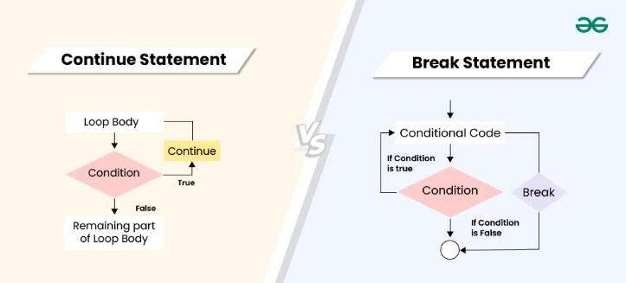

21

- Definition

ACTIVITY 8

At Command

The AT command is a scheduling utility that enables users to execute a command, program, or script at a specified date and time.
It is mainly used for:
  - Running batch jobs
  - Automating tasks
  - Scheduling system maintenance
  - Running programs in the background

Syntax of AT Command
General syntax:
at [time] [options] Example:
at 10:30
This command schedules a task to run at 10:30 AM.
After entering the command, the user can type the commands that need to be executed at that time.

Working of AT Command
Steps involved in using the AT command:
- User enters the AT command with a specified time.
- The system waits for commands to be entered.
- The commands are stored in a job queue.
- At the scheduled time, the operating system executes the stored commands automatically.

Examples of AT Command

22

Example 1: Schedule a message
at 6:00 PM
echo "Backup Started"
This command displays the message Backup Started at 6:00 PM.

Example 2: Run a program
at 8:00 AM
backup.sh
This schedules a backup script to run at 8:00 AM.

AT Command Options
Some common options used with the AT command include:

Option Function
Atq Displays scheduled jobs atrm Removes scheduled jobs at -l Lists pending jobs
at -r Deletes a scheduled job
Example:
atq
Displays the list of all scheduled jobs.

Uses of AT Command
The AT command is useful in many situations such as:
- System maintenance tasks
- Automatic backups
- Running scripts at scheduled times
- Scheduling batch processing jobs
- Automating repetitive tasks

23

Advantages of AT Command
- Automates system tasks.
- Saves time by scheduling tasks.
- Allows tasks to run without user intervention.
- Improves system efficiency.
- Useful for system administrators.

Limitations
- Requires proper time scheduling.
- Some systems require administrative privileges.
- Less flexible compared to advanced schedulers like Cron in Linux.

Applications
AT command is commonly used for:
  - Data backup
  - System updates
  - Running scripts automatically
  - Server maintenance tasks
  - Batch job execution

Conclusion
The AT command is a useful scheduling tool in operating systems that allows users to execute commands at a specified time. It helps automate tasks, reduce manual effort, and improve system efficiency. Although more advanced schedulers exist, the AT command remains a simple and effective method for scheduling one-time tasks.

24

- Definition

ACTIVITY 9

IP Address

An IP address is a unique address assigned to each device in a network that uses the Internet Protocol to identify and communicate with other devices.
Example of an IP address:
192.168.1.1
This address identifies a device in a network.

Purpose of IP Address
The main purposes of an IP address are:
  - Identification – Identifies each device on a network.
  - Location Addressing – Indicates where the device is located in the network.
  - Communication – Enables data transfer between devices.
Without IP addresses, computers would not be able to send or receive data over networks or the internet.

Types of IPAddresses
- IPv4 (Internet Protocol Version 4)
IPv4 is the most widely used IP addressing system.

Characteristics
  - Uses 32-bit address
  - Represented in decimal format
  - Divided into four octets Example:
192.168.10.25
Range of each octet: 0 – 255

25

IPv6 (Internet Protocol Version 6)
IPv6 was developed to overcome the limited address space of IPv4. Characteristics
  - Uses 128-bit address
  - Written in hexadecimal format
  - Separated by colons

Example:
2001:0db8:85a3:0000:0000:8a2e:0370:7334
IPv6 provides a much larger number of possible addresses.

Types of IP Address Allocation
- Static IP Address
  - Assigned manually
  - Does not change
  - Used for servers and network devices

Dynamic IP Address
  - Assigned automatically by a server
  - Changes periodically
  - Commonly used in home networks
Dynamic IP addresses are usually assigned using **Dynamic Host Configuration Protocol (DHCP).

Public vs Private IP Addresses Public IP Address
- Assigned by Internet Service Provider
- Used on the internet
- Globally unique

26

Private IP Address
- Used within private networks
- Not accessible directly from the internet

Common private IP ranges:
10.0.0.0 – 10.255.255.255
172.16.0.0 – 172.31.255.255
192.168.0.0 – 192.168.255.255

Structure of an IPAddress
An IP address consists of two parts:
  - Network ID – Identifies the network.
  - Host ID – Identifies the device within that network.

Example:
192.168.1.25
    - Network ID → 192.168.1
    - Host ID → 25

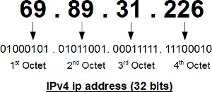

27

- Definition

ACTIVITY 10

Hackers.

A hacker is an individual who uses computer programming and networking knowledge to access computer systems, sometimes without permission, to test, exploit, or improve system security.



Types of Hackers
- White Hat Hackers
White hat hackers are ethical hackers who work to improve security by identifying vulnerabilities in systems.
Characteristics:
  - Authorized access
  - Work legally
  - Help organizations improve security Example: Security experts hired to test systems.

Black Hat Hackers
Black hat hackers perform illegal activities such as stealing data, damaging systems, or spreading malware.
Characteristics:

28

  - Unauthorized access
  - Malicious intentions
  - Violate computer security laws

Examples of attacks:
  - Data theft
  - System damage
  - Identity theft

Grey Hat Hackers
Grey hat hackers operate between white hat and black hat hackers.

Characteristics:
  - May access systems without permission
  - Usually do not have malicious intent
  - Sometimes reveal vulnerabilities to organizations

Methods Used by Hackers
Hackers use different techniques to gain unauthorized access.

Password Cracking
Attempting to guess or decode user passwords.

Phishing
Tricking users into providing sensitive information such as passwords or bank details.

Malware
Installing malicious software such as:
  - Viruses
  - Worms
  - Trojans

Network Attacks

29

Intercepting or manipulating network traffic.

Exploiting System Vulnerabilities
Using weaknesses in operating systems or software to gain access.

Impact of Hacking
Hacking can cause serious problems such as:
  - Loss of sensitive data
  - Financial losses
  - Damage to computer systems
  - Identity theft
  - Privacy violations

Protection Against Hackers
Operating systems use various security mechanisms to prevent hacking.

Strong Passwords
Using complex passwords reduces unauthorized access.

Firewalls
A firewall monitors and controls network traffic.

Antivirus Software
Protects systems from malicious programs.

Software Updates
Regular updates fix security vulnerabilities.

Access Control
Limits system access to authorized users only.

30

- Definition

ACTIVITY 11

System Maintenance.

System maintenance is the process of regularly checking, updating, repairing, and optimizing a computer system to ensure that it operates smoothly and efficiently.

Objectives of System Maintenance
The main objectives include:
  - Improve system performance
  - Ensure system security
  - Prevent system failures
  - Extend hardware and software life
  - Protect important data

- Types of System Maintenance
- Preventive Maintenance
Preventive maintenance is performed before problems occur to avoid system failures. Examples:
  - Updating software
  - Running antivirus scans
  - Cleaning unnecessary files

Corrective Maintenance
Corrective maintenance involves fixing errors or problems after they occur.

Examples:
  - Fixing system errors
  - Repairing damaged files
  - Managing system

31

  - Removing malware

Adaptive Maintenance
Adaptive maintenance involves modifying the system to adapt to new environments or technologies.

Examples:
  - Installing new hardware drivers
  - Updating operating systems
  - Upgrading applications

Perfective Maintenance
Perfective maintenance focuses on improving system performance and efficiency. Examples:
  - Optimizing system settings
  - Increasing memory
  - Updating applications

System Maintenance Tasks
- Disk Cleanup
Removes temporary files and unnecessary data to free disk space.

Disk Defragmentation
Reorganizes fragmented data on the disk to improve access speed.

Software Updates
Installing updates improves security and performance.

Virus Scanning
Scanning the system to detect and remove viruses and malware.

Backup and Recovery

32

Regularly backing up important data to prevent data loss.

Monitoring System Performance
Checking CPU usage, memory usage, and disk usage to maintain system efficiency.

System Maintenance Tools
Operating systems provide tools to help maintain the system. Examples include:
  - Disk Cleanup
  - Task Manager
  - System Monitor
  - Backup Utilities
These tools help detect problems and maintain system stability.
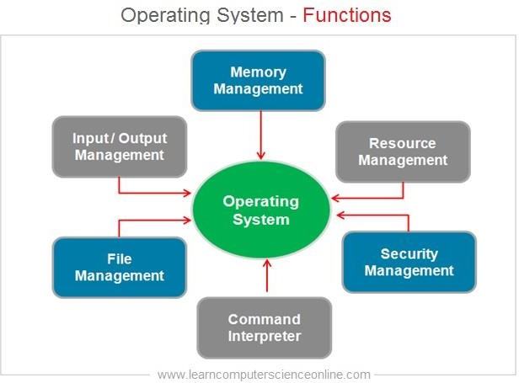

33

- Definition

ACTIVITY 12

FTP (File Transfer Protocol)

FTP (File Transfer Protocol) is a communication protocol used for transferring files between a
client computer and a server over a TCP/IP network. It allows users to:
  - Upload files to a server
  - Download files from a server
  - Manage files on remote systems

Components of FTP
FTP consists of two main components:

FTP Client
The FTP client is the program used by the user to connect to an FTP server. Example FTP clients:
  - Command-line FTP
  - Graphical FTP software

FTP Server
The FTP server stores files and provides access to users who want to upload or download files. The server manages:
  - User authentication
  - File storage
  - File transfer operations

Working of FTP
FTP works using a client–server model. Steps involved:

34

- The user starts an FTP client.
- The client connects to the FTP server.
- The user logs in using a username and password.
- The user can upload, download, or manage files.
- After completing tasks, the connection is closed.
FTP uses TCP (Transmission Control Protocol) to ensure reliable data transfer.

Modes of FTP Transfer
- Active Mode
In active mode:
  - The client opens a command channel.
  - The server initiates the data connection.

Passive Mode
In passive mode:
  - The client opens both command and data connections.
  - Used when firewalls block server connections.

Types of FTP Access
- Anonymous FTP
Allows users to access files without a personal account. Users log in using the username anonymous.

Authenticated FTP
Requires a username and password for access. Used for secure file transfers.

Advantages of FTP
- Fast file transfer

35

- Reliable data transmission
- Supports large file transfers
- Allows remote file management
- Widely supported by operating systems

Disadvantages of FTP
- Data is not encrypted by default
- Security risks if used without protection
- Requires proper configuration
Because of security issues, newer protocols like Secure File Transfer Protocol (SFTP) are often used.

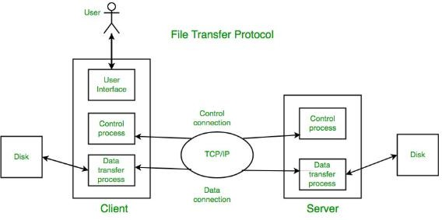

36

- Definition

ACTIVITY 13

Disk Partition.

A disk partition is a logical division of a physical storage device that allows the operating system to treat each partition as a separate disk.

Purpose of Disk Partitioning
The main purposes include:
  - Organizing data efficiently
  - Installing multiple operating systems
  - Improving system performance
  - Enhancing data security
  - Simplifying backup and recovery
For example, one partition can be used for the operating system, while another can store user data.

Types of Disk Partitions
- Primary Partition
A primary partition is the main partition that can contain an operating system. Characteristics:
  - Bootable partition
  - Used to install operating systems
  - A disk can contain limited primary partitions

Extended Partition
An extended partition is used to create additional partitions beyond the limit of primary partitions.

Characteristics:

37

  - Cannot store data directly
  - Contains logical partitions

Logical Partition
Logical partitions are created inside an extended partition. Characteristics:
  - Used for storing files and applications
  - Multiple logical partitions can exist

Disk Partitioning Process
The general steps involved are:
- Identify the available disk space.
- Divide the disk into partitions.
- Assign sizes to each partition.
- Format the partition with a file system.
- Use the partition for storing data or installing an operating system.

File Systems Used in Partitions
After partitioning, each partition must be formatted with a file system. Common file systems include:
  - NTFS
  - FAT32
  - ext4
These file systems help the operating system organize and access stored data.

Disk Partitioning Tools
Operating systems provide tools for disk partitioning.

38

Examples:
  - Disk Management tool in Microsoft Windows
  - fdisk and parted commands in Linux
These tools allow users to create, delete, resize, and manage partitions.

Advantages of Disk Partitioning
- Better organization of files
- Allows installation of multiple operating systems
- Improves system performance
- Simplifies data backup
- Protects data from system crashes

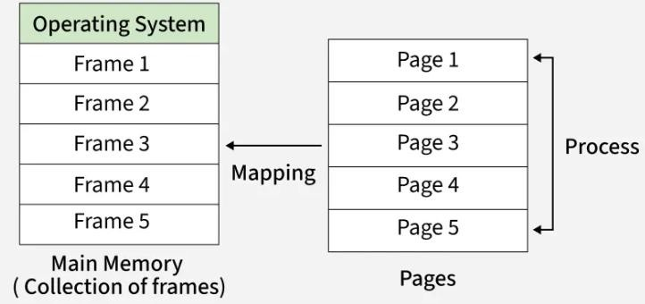

39

40

